1. Environment:
2. JRE 1.7 (1.7.0_45)
3. Spring 4.x
4. Hibernate 4.x
5. Jersey RESTful Web Services 2.14
6. MySQL
7. Tomcat Server 7.0
8. How to create Database and deploy the REST API?

Download "Deployment" directory from Bitbucket, which contains StoreLocator.war and create-causecodedb-design.sql files.

a. Create Database and tables - run below command on MySql cmd

**mysql> source create-causecodedb-design.sql**

b. Copy StoreLocator.war file into "/webapps" of Tomcat server

e.g. C:\Program Files\Apache Software Foundation\Tomcat 7.0\webapps

1. How to test the REST API?

You can use any REST Client e.g. For Chome - Postman, For Firefox - HttpRequester

1. TEST CASES

* POST - request to add new store

http://localhost:8080/StoreLocator/webapi/stores/

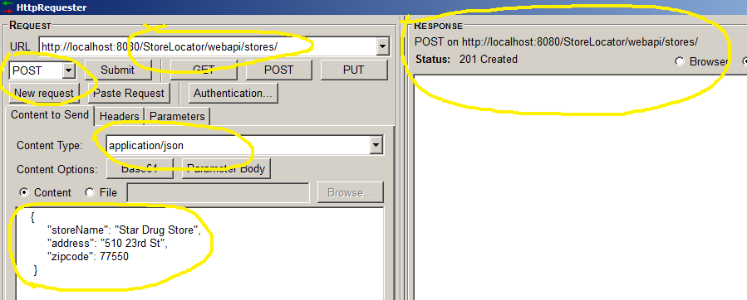

* PUT - update the existing store using

URL - http://localhost:8080/StoreLocator/webapi/stores/{StoreID}

e.g. http://localhost:8080/StoreLocator/webapi/stores/16

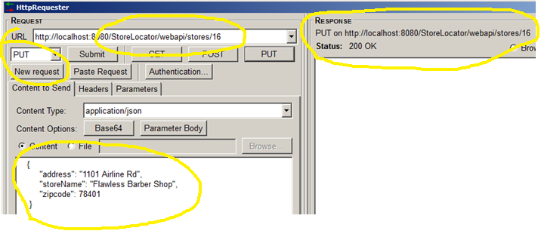

* DELETE - to delete store using

URL - http://localhost:8080/StoreLocator/webapi/stores/{StoreID}

e.g. http://localhost:8080/StoreLocator/webapi/stores/16

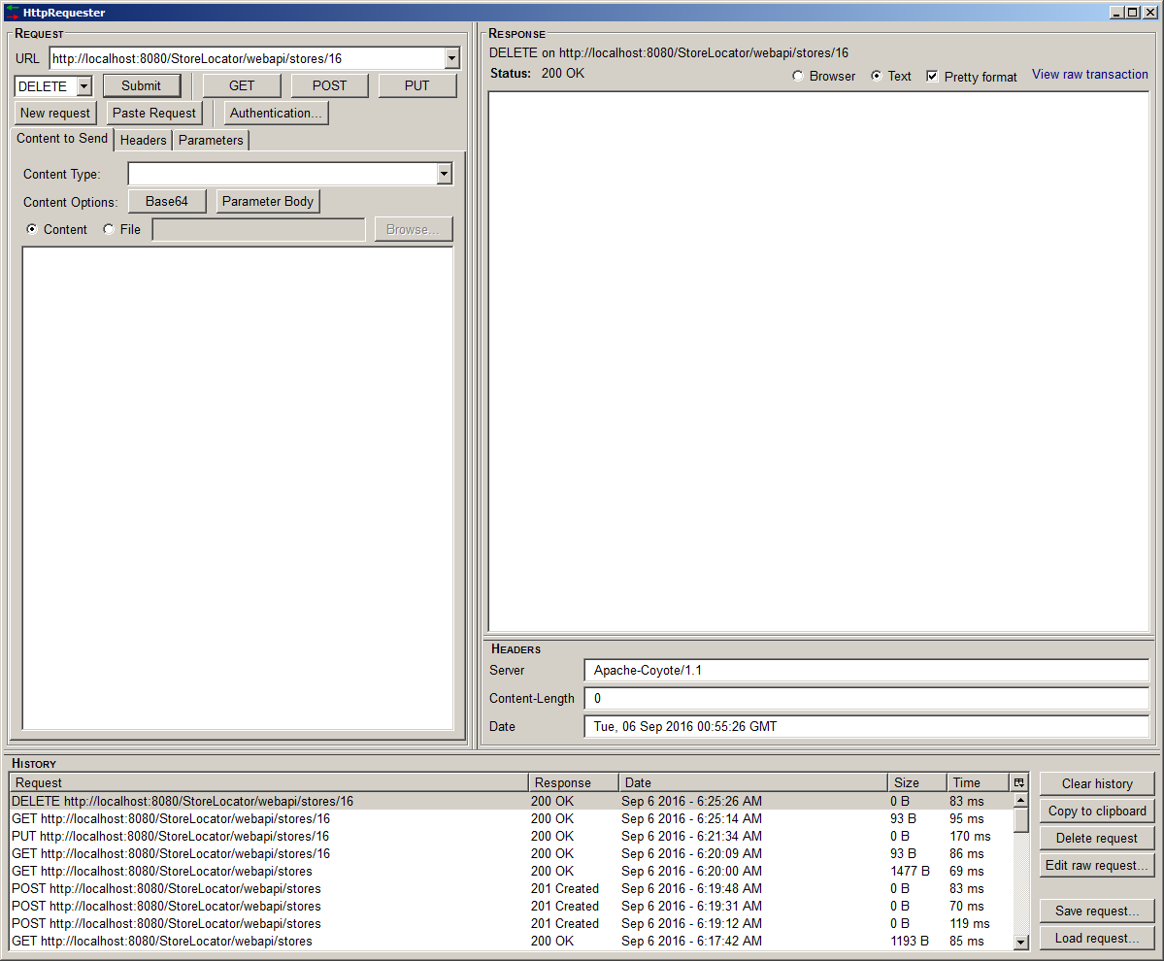

* GET: get Store detail by its ID

URL - http://localhost:8080/StoreLocator/webapi/stores/{StoreID}

e.g. http://localhost:8080/StoreLocator/webapi/stores/**16**

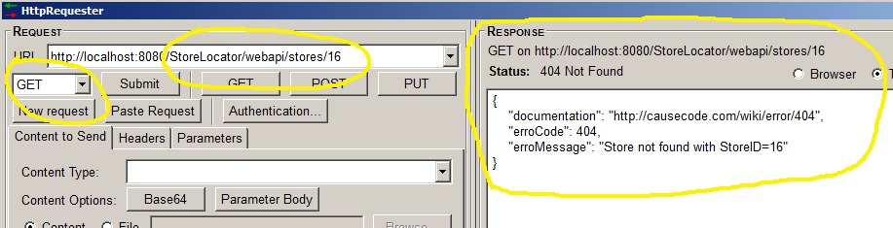

http://localhost:8080/StoreLocator/webapi/stores/**15**

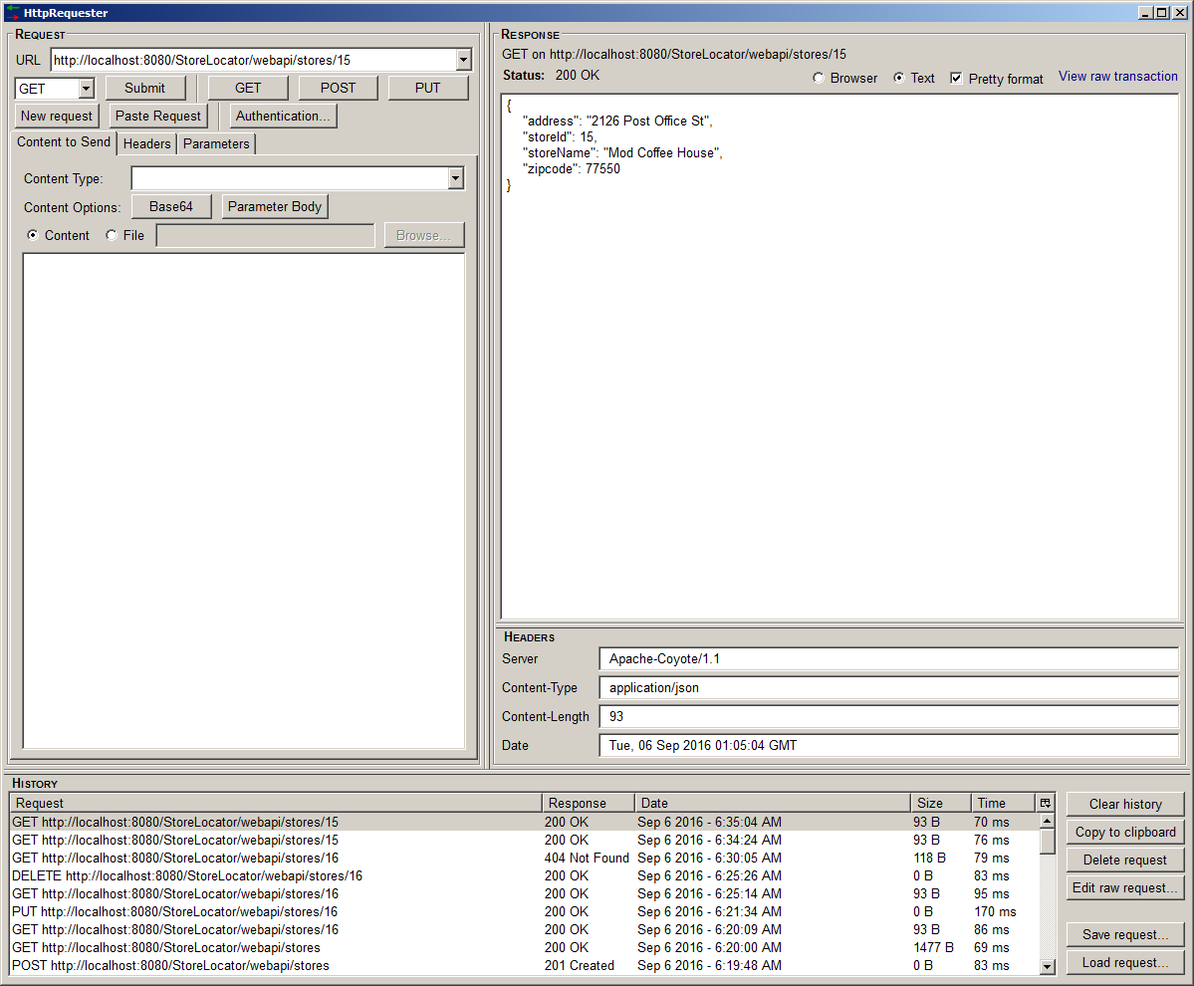

* GET: request to get list of all Stores

e.g. http://localhost:8080/StoreLocator/webapi/stores

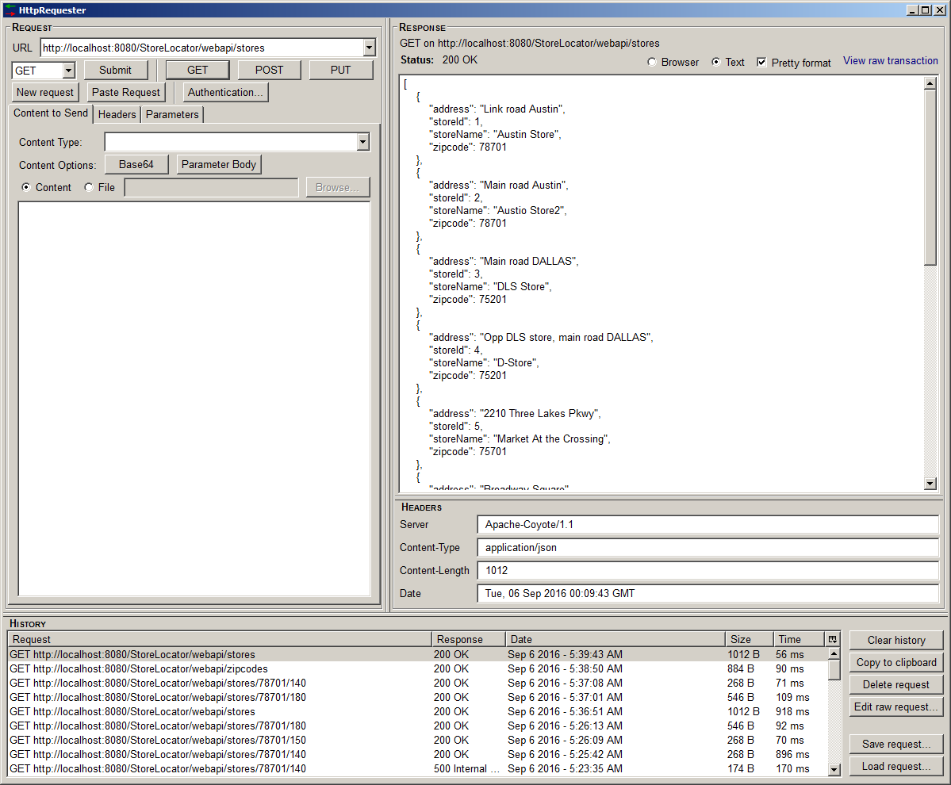

* POST - request to add new ZipCode

e.g. http://localhost:8080/StoreLocator/webapi/zipcodes/

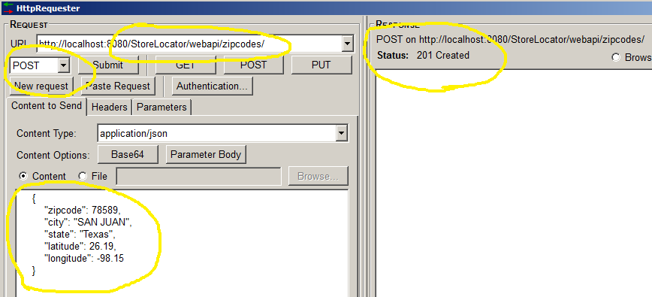

* PUT/DELETE - similar to update/delete command of store, you can use below URL to update/delete ZipCode

PUT - http://localhost:8080/StoreLocator/webapi/zipcodes/78589

DELETE - http://localhost:8080/StoreLocator/webapi/zipcodes/78589

* GET: request to fetch all zip code with details

e.g. http://localhost:8080/StoreLocator/webapi/zipcodes

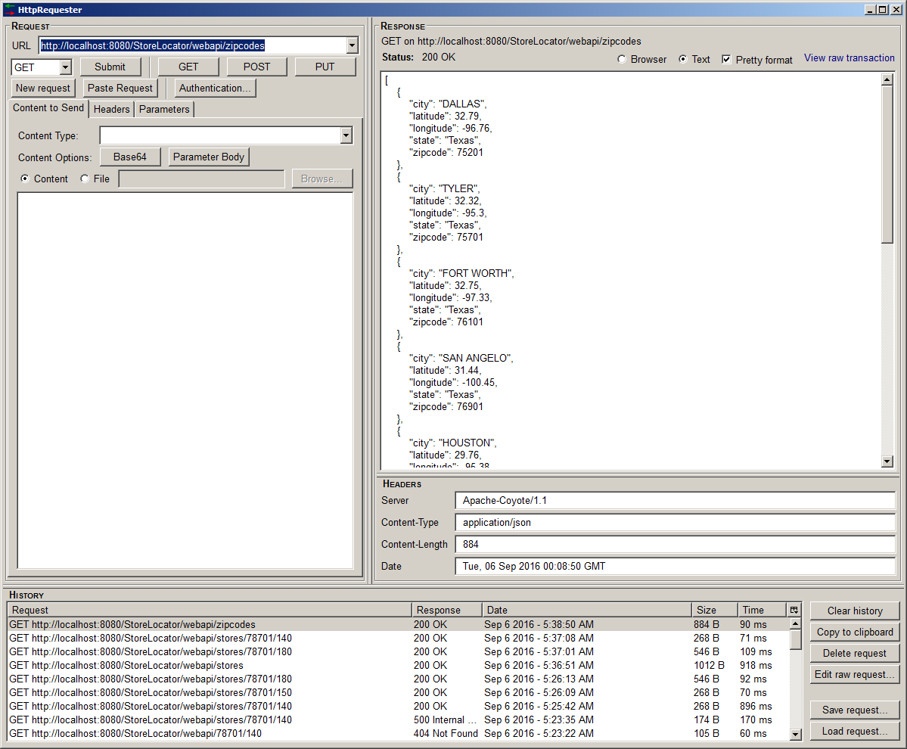

* **GET: request to find stores within 140 miles from zipcode 78701**

URL - http://localhost:8080/StoreLocator/webapi/stores/{zipcode}/{miles}

e.g. http://localhost:8080/StoreLocator/webapi/stores/78701/140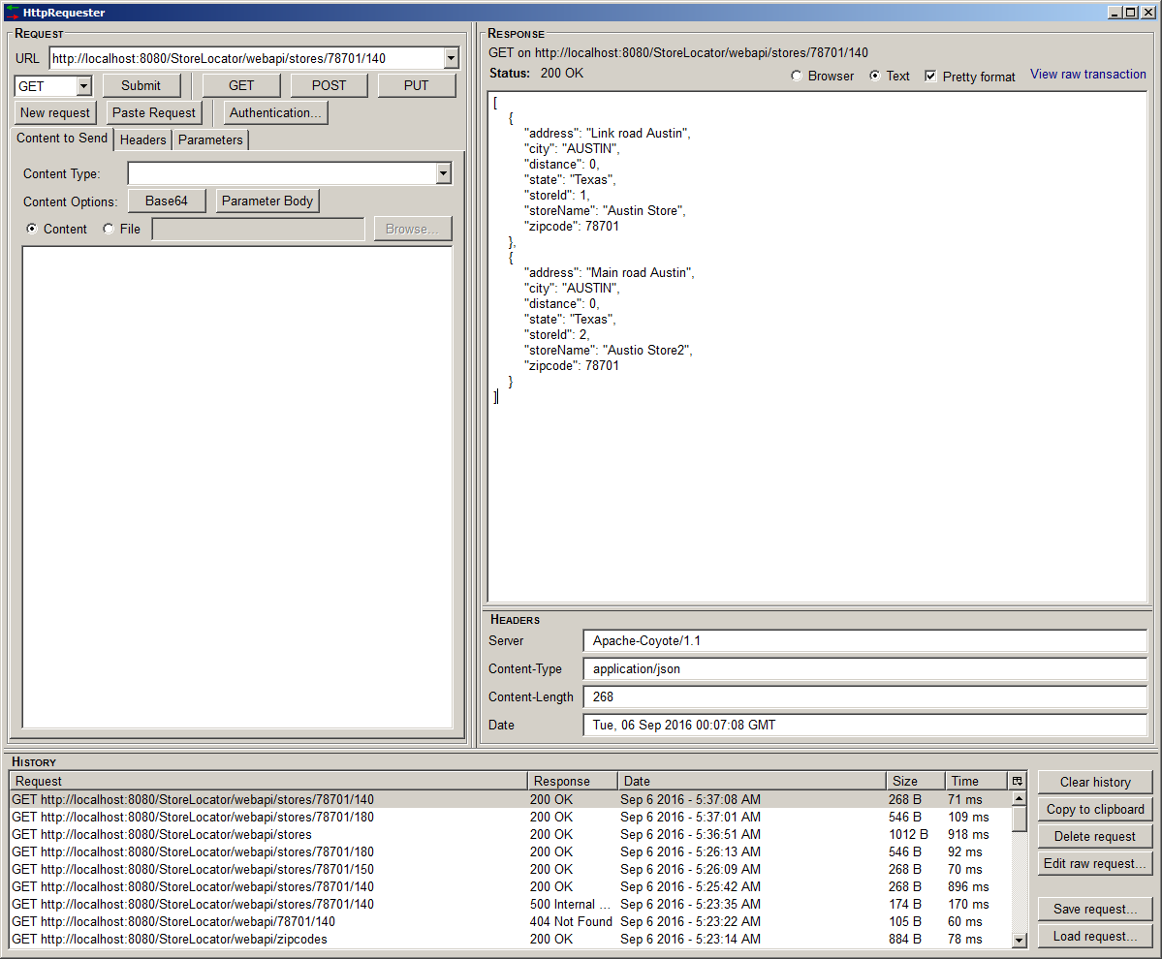

* **GET: request to find stores within 200 miles from zipcode 77550**

e.g. http://localhost:8080/StoreLocator/webapi/stores/77550/200

